**Preparation of 2'-13C-L-Histidine Starting from 13C-Thiocyanate: Synthetic Access to Any Site-Directed Stable Isotope Enriched L-Histidine**

**[ Source:** [**https://www.researchgate.net/publication/229484314_Synthesis_of_Lhistidine_specifically_labelled_with_stable_isotopes**](https://www.researchgate.net/publication/229484314_Synthesis_of_Lhistidine_specifically_labelled_with_stable_isotopes) **]**

For the access to stable isotope labeled 2-13C 1-benzyl-5-chloromethylimidazolium chloride (9a) the reactions depicted in Scheme 1 were optimized with natural abundance reagents. Potassium thiocyanate (2) is reacted with benzyl chloride in o-dichlorobenzene in the presence of the phase transfer catalyst bis(triphenyl) phosphoranylidene ammonium chloride. According to a known procedure a mixture containing mainly benzyl isothiocyanate and some benzyl thiocyanate is obtained [7]. This isomeric mixture is treated with glycine amide HCl 3 at pH 8.5 [8]. The product is recrystallized from acetone and benzyl thiourea 4 is thus obtained.

**Scheme 1.** The preparation of 1-benzyl-5-chloromethylimidazolium chloride 9 starting from potassium thiocyanate 2 giving stable isotope incorporation in 9 at position 1 and/or 2.

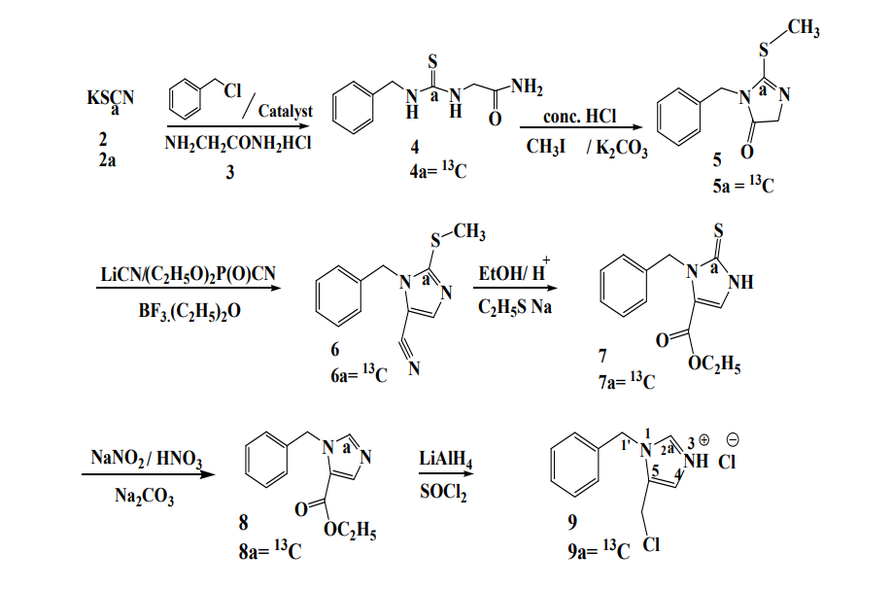

For the cyclisation of 4 it is dissolved in acetone and aqueous HCl [9]. When the reaction is finished the 1-benzyl-2-thioxoimidazolium-4-one is obtained by extraction (not shown in Scheme 1). The conversion of benzyl isothiocyanate and 1-benzyl-2-thioxoimidazolium-4-one is analogous to the reaction that takes place in the Edman sequencing [10] of proteins and is a high yielding, efficient process. The conversion can also be affected with glycine instead of 3 [8]. 1-Benzyl-2-thioxoimidazolium-4-one dissolved in acetonitrile is treated with methyl iodide in the presence of potassium carbonate under known conditions to form 1-benzyl-2-(methylthio)-imidazol-5- ketone (5) [10]. A conversion of aromatic ketones into unsaturated nitriles has been described [11]. We hoped that the amide function of 5 would undergo a similar conversion with diethyl phosphoro-cyanidate. Compound 5 is treated with diethyl phosphorocyanidate in the presence of LiCN in THF. After evaporation of THF the product extracted with ethyl acetate is the cyanohydrin phosphate corresponding to 5. Treatment of this product in benzene with boron trifluoride etherate results in the elimination of diethyl phosphate giving the aromatic nitrile 6, which is then dissolved in ethanol and after the addition of concentrated sulphuric acid, the solution is refluxed. After the workup crystalline ethyl-1-benzyl-2-ethyl thio-5-imidazole carboxylate is obtained (not shown in Scheme 1). During the reaction of 6 with acidified ethanol not only the expected conversion of the nitrile function into the ethyl carboxyl function, but also acid catalysed conversion of the methylthio group into an ethylthio function had taken place. This simple conversion of 6 into ethyl-1-benzyl-2-ethyl thio-5-imidazole carboxylate was found after failed attempts of DIBAL-H reduction and Raney nickel desulphurization of 6. Ethyl-1-benzyl-2-ethyl thio-5-imidazole carboxylate is treated with sodium ethylthiolate in DMF [12]. This gives ethyl-1-benzyl-2,3-dihydro-2-thioxo-5-imidazole-carboxylate 7 after crystallization. This compound was an intermediate in our earlier preparation of [1'-5' N] and [3'-5' N] L-histidine [6] and can be converted into 1-benzyl-5-chloromethylimidazolium chloride (9). The imidazolium chloride salt 9 is treated according to Scheme 2 with tert-butyl(N-diphenyl methylene) glycinate (10) under O’Donnell conditions [4]. The protected histidine derivative 11 is obtained in high yield. Acid catalysis removes the tert- butyl ester and the amino protection. A final hydrogenlysis with palladium on activated charcoal gives L-histidine (1) with **99% chemical purity and 99% optical purity.**

**Scheme 2**. The conversion of 1-benzyl-5-chloromethylimidazolium chloride (9) under O’Donnell conditions into the protected L-histidine

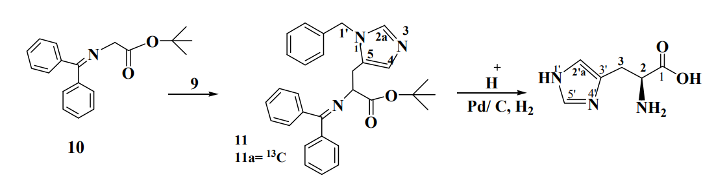

Compound 11. Final deprotection leads to stable isotope enriched L-histidine (1a). Compound 7 is treated briefly with NaNO2/HNO3 giving desulphurization to 1-benzyl-5-carboethoxyimidazole (8). Subsequently reduction of 8 with LiAlH4 converts the ethyl function into the methylene alcohol function. Treatment of the latter product with SOCl2 gives the imidazolium chloride salt 9. The analytical data of 9 are within experimental error in agreement with those reported by us before [6].